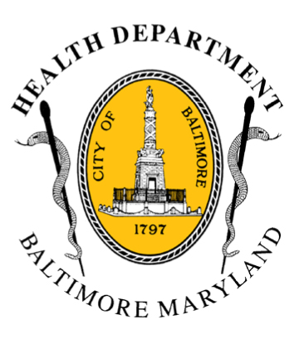
BCHD PRESS RELEASE
Baltimore City Health Department
1001 E. Fayette Street • Baltimore, Maryland 21202
Stephanie Rawlings-Blake, Mayor
Leana Wen, M.D., Commissioner of Health

FOR IMMEDIATE RELEASE
Media Contact: Michael Schwartzberg, PIO
O: (443) 984-2623 C: (443) 462-7939 E: michael.schwartzberg@baltimorecity.gov
Mayor and Health Commissioner Holding Second Community Forum
For Heroin Treatment and Prevention Taskforce
BALTIMORE, MD (April 20, 2015) – This week, Mayor Stephanie Rawlings-Blake and Baltimore Health Commissioner Dr. Leana Wen will be holding the second community forum for the Heroin Treatment and Prevention Taskforce.
The taskforce was convened last fall by Mayor Rawlings-Blake to address the critical problem of opioid addiction. Its goal was to study the problem of heroin addiction and propose solutions for improving access to effective treatment and neighborhood compatibility.
This is the second of two community meetings to hear from community stakeholders regarding overdose issues. The meeting will be held April 23 from 6:30 pm – 8:00 pm at East Baltimore Development Inc., 1731 E. Chase Street and is open to the public. The meeting will include community conversation around three issues: Preventing fatal heroin overdoses; increasing access to quality treatment; and improving neighborhood compatibility.
“Preventing heroin addiction and improving access to treatment are top health priorities for my administration and for our city,” said Mayor Rawlings-Blake. “We can’t do this work in a vacuum. This is an opportunity to continue to engage our community in efforts to address addiction, save lives, and strengthen our city.”

In 2014, Baltimore experienced 226 deaths from drug and alcohol overdose between January and September, 143 of which were heroin-related. There were 246 deaths related to drugs and alcohol in Baltimore City in 2013, with 150 of those due to heroin. The taskforce estimates that Baltimore has 19,000 people who have used heroin in the last year.
- more -

2-2-2

“We had an excellent first forum in northwest Baltimore,” said Dr. Wen. “Our community members were very candid and open in sharing their ideas about how to prevent this terrible tragedy of overdose deaths. We look forward to a similar dialogue on the east side of the city to figure out how we can address this critical problem of heroin addiction.”

Speakers at the first meeting included advocates, peer addiction counselors, doctors, hospital representatives, researchers, individuals in active recovery and other community members.

“It’s critical for us to get input from the community and have our residents shape the report,” Dr. Wen added. “Our Mayor and our city do not take a back seat to public health. The last thing we want is to have a report that will just sit on a shelf, when we have people dying every day. Our taskforce is going to produce actionable items that will make a real difference to our city.”

The taskforce will release final recommendations this summer.

###

